Project Planning Phase
Project Planning Template (Product Backlog, Sprint Planning, Stories, Story Points)
Date: 03 October 2026

Team ID: SWTID-2026-4310
Project Name: Implement Client Script & UI Policy (Incident) Program / Module: ServiceNow System Administrator Maximum Marks: 5 Marks

Product Backlog, Sprint Schedule, and Estimation (4 Marks)
Use the below template to create product backlog and sprint schedule.

Sprint | Functional Requirement (Epic) | User Story Number | User Story / Task | Story Points | Priority | Team Members
Sprint-1 | UI Policy Setup | USN-1 | As an administrator, I can create a UI Policy on the Incident table. | 2 | High
Sprint-1 | UI Policy Setup | USN-2 | As an administrator, I can create a UI Policy Action for the Urgency field. | 2 | High
Sprint-1 | Client Script Implementations | USN-3 | As an administrator, I can create an onChange Client Script for Incident form behaviour. | 3 | High
Sprint-2 | Client Script Implementations | USN-4 | As an administrator, I can create an onSubmit Client Script for save validation. | 3 | High
Sprint-2 | Client Script Implementations | USN-5 | As an administrator, I can create an onCellEdit Client Script. | 3 | Medium
Sprint-2 | Testing & Enforcement | USN-6 | As an administrator, I can test mandatory fields, save validation, reverse conditions, list-edit blocking, and form-based updates. | 5 | High

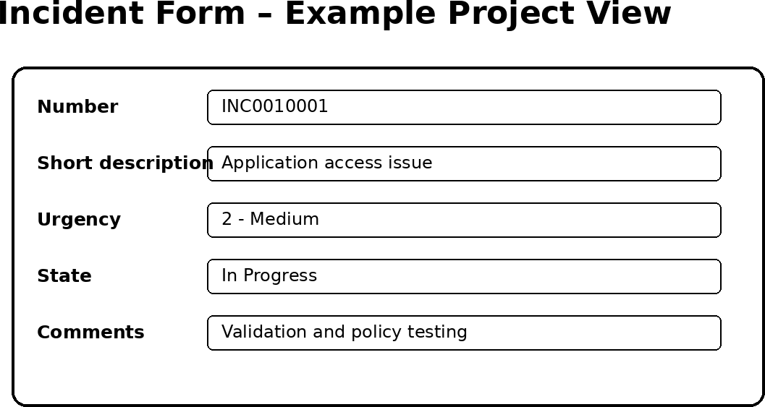

Project Tracker, Velocity & Burndown Chart: (4 Marks)

Sprint | Total Story Points | Duration | Sprint Start Date | Sprint End Date (Planned) | Story Points Completed (as on Planned End Date) | Sprint Release Date (Actual)
Sprint-1 | 10 | 6 Days | 05 Oct 2026 | 10 Oct 2026 | — | —
Sprint-2 | 13 | 6 Days | 12 Oct 2026 | 17 Oct 2026 | — | —

Velocity: Total planned story points = 10 + 13 = 23. With 2 planned sprints, average planned velocity = 23 / 2 = 11.5 story points per sprint.

Burndown Chart:
A burndown chart is a graphical representation of work left to do versus time. The chart below is a project-planning illustration based on the planned story-point totals; actual completion values should be updated after each sprint.
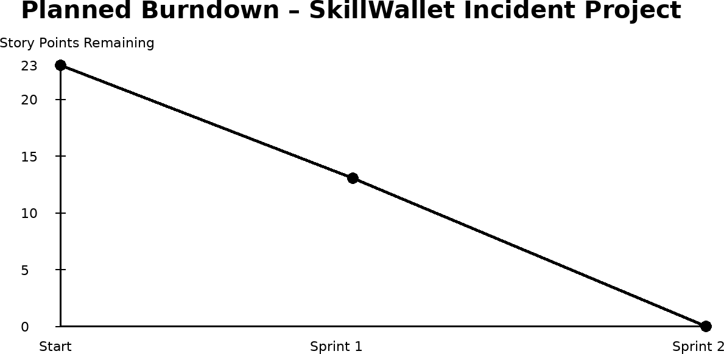

Project References & Notes
Project Status: Group not formed yet; the project is pending team setup or project start.
Next Step: Use “Invite Member” to form a team or “Start Group Project” to proceed individually. Once started, assign the milestone stories to team members and begin the workspace activities.

Project Milestone Summary
- Create UI Policy on the Incident table.
- Create UI Policy Action for the Urgency field.
- Create an onChange Client Script.
- Create an onSubmit Client Script for save validation.
- Create an onCellEdit Client Script.
- Test mandatory field enforcement, form save validations, reverse condition behaviours, list-edit blocking, and form-based updates.

Planning Basis
The layout, headings, terminology, and tracker structure are adapted directly from the uploaded Project Planning Template, including Product Backlog, Sprint Schedule, User Stories, Story Points, Project Tracker, Velocity, and Burndown Chart sections.
The uploaded template specifies columns for Sprint, Functional Requirement (Epic), User Story Number, User Story / Task, Story Points, Priority, and Team Members, followed by sprint tracking and velocity sections.

